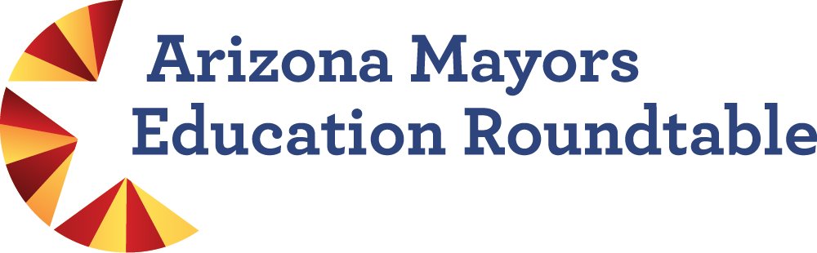

Arizona Board of Regents & League Panel
NOTES
3 August 2023 | 9:00–10:00 AM
Zoom Meeting
Arizona Board of Regents (ABOR) Overview & Initiatives
Speaker: John Arnold, Executive Director
Education, attainment, and workforce development are key to the long-term prosperity of the state. Arizona is currently 26,000 four-year degrees short annually of meeting the economic demands of the current economy. ABOR is reaching out to groups like the Roundtable to learn how best to communicate and work with mayors and municipalities to advance this critical issue.

Key Initiatives
- Arizona Promise Program – statewide scholarship program that guarantees tuition and fees at our universities for Pell eligible students who enroll the next semester following high school graduation; in the early stages of operation; seek to work with partners to have a fully realized promise program; conducting market research to test other potential elements; starting to market the concept to middle school and low-income families.
- Healthcare – announced new medical school for ASU; seek to double medical enrollments at UofA and expand allied health and nursing programs; NAU to expand healthcare initiatives this fall; significant barrier to healthcare initiatives is solving financial shortfalls and residency experiences across the board; launching study with health networks and governor’s office to identify the shortfall in this space and understand the full scope of the problem.
- Access – need more of everything, financial and practical access; board supportive of community colleges offering four-year degrees; we have limited educational product compared to other states; working with partners to look at the full scope of educational product needed, how best to provide it, and who is best positioned to provide it; how to expand our robust research universities with multiple locations and community college system to provide online, hybrid, and in-person opportunities. For example, only 50% of Pell eligible students who complete FAFSA, apply to university and are accepted actually end up enrolling. Part of the issue is the practical ability to attend; looking at these populations and products to expand access to them.
- Community Grant Program – set aside research dollars to catalyze relationships between universities and municipalities; we are looking for problems that municipalities have that ABOR can help address; began with state agencies, studying water issues and forever chemicals in water supply, valley fever and dust mitigation, firefighter blood and contaminants; working with counties on recruiting and retaining public personnel in rural areas; small amount of funds available for more municipal projects. Contact Page Gonzales, Julie Sainz, or Monica Trejo at ABOR for additional information.

Discussion
Casa Grande works with districts and the community college to address these and other issues. Municipalities can serve as a mouthpiece, support mechanism, source of funding and/or grant writing, communicator, collaborator, and convener.
Central Arizona College (CAC) launched Promise for the Future, now called the Pinal Promise, in 2001. More students might elect to participate when CAC offers additional four-year degrees. The pandemic changed how postsecondary learners prefer to interact with institutions. Students expressed more interest in hybrid and online experiences that meet them where they are. CAC will offer an affordable bachelor’s degree in nursing. Need to dig deeper; offered free tuition for two years and enrollment stayed flat, there are other motivators to get people into college. Dual enrollment numbers have tripled over the past two years. Dual enrollment struggled in the past due to faculty qualifications. HLC passed policy that changed master’s degree or 18 requirement; now an institution can determine instructor qualifications.
Drive 48 partnership with City of Casa Grande enabled CAC to train almost 3,000 individuals to work at Lucid. The City supports the operation of the workforce center. President Elliott told the group “If it sounds crazy, do it.” There are many unique opportunities to grow attainment. CAC is also working on reverse transfer to auto-award a degree, credential, or certificate when students return with university credits. The state needs a stronger focus on this issue. CAC seeks to train local residents for local jobs. Also working with local healthcare providers to offer opportunities at a new training center. Education and workforce development are the same.
Monica Trejo, Director of Community Engagement, Arizona Board of Regents, will reach out to mayors and their staff for additional input. John Saltonstall welcomes the opportunity to explore a partnership with ABOR as Flagstaff is currently undertaking a workforce analysis. We will continue conversations about how cities and ABOR can work together during the conference.

2023 League Annual Conference: Panel Session
Conference Information
Special Guests:
Fred DuVal, Chair, Arizona Board of Regents
Valerie Shaffer, Horizon Strategies
The conference attracts close to 2,000 attendees from 91 municipalities, mayors and councilmembers attend along with key staff; largest gathering of officials in the state. This is the third year that Horizon Strategies has assisted; worked with the Roundtable on a session for the 2022 conference. This year’s event takes place in Tucson at the JW Marriott Starr Pass Resort and Spa. Panel sessions are scheduled for Wednesday and Thursday; participants self-select which concurrent session to attend; could have up to 100 participants.
The ABOR/Roundtable panel session is scheduled for 1:30 p.m. on Wednesday, August 30. Mayors want to learn more about the work of the Roundtable and how to connect, and get an update from ABOR including the state of education, shared priorities, and how to tap into resources. ABOR Chair Fred DuVal will moderate the panel session. Roundtable mayors serving as panelists include Mayor McFarland, Mayor Gallego, Mayor Besich, and Mayor Giles. Both ABOR and the Roundtable will provide overviews and describe key initiatives followed by questions to panelists. Valerie and team will determine the format and draft questions to be finalized during the August 21 preparation meeting.
The Roundtable wants to communicate how municipalities can be part of the education system. Mayor Giles might describe how to develop relationships with superintendents and the Education and Workforce Roundtable. Mayor McFarland might discuss how education and workforce development systems work together to implement Drive 48.
Mayor Dickey, former school board member, meets with the Fountain Hills superintendent at least quarterly. Declining enrollment is an issue they are addressing. Need to be vocal about supporting education, an economic driver, and supporting bond issues by writing statements and holding pre-election rallies. A question to the panel might be “How are/can municipalities support school bond issues?”
In May, the Roundtable held two meetings at the Helios Decision Center, a question about data would be meaningful. For example, how are teams strategically looking at data to inform decisions? Additionally, all Roundtable cities and towns are committed to the Achieve60AZ action plan and Education Progress Meter indicators. An update on where we are now would be useful. Also, how are municipalities supporting the Achieve60AZ initiative? Education Forward could provide updates on progress and initiatives. Valerie will invite Rich Nickel to the August 21 preparation call. We can feed the information provided by Education Forward to the four mayors to integrate into their talking points. Education Forward could provide a handout with progress meter data and key findings from the Billions to Gain report along with Education Forward contact information. Valerie suggested offering an Achieve60AZ and data workshop at next year’s League Conference.
ABOR Chair Fred DuVal’s goal for the panel session is to elevate best practices, touch on topics with the broadest applicability to participants, and elevate our partnerships. Valerie and team will work with the League and Greater Phoenix Economic Council to explore the possibility of holding follow-up webinars on topics such as Achieve60AZ, Billions to Gain report, and available data. This way mayors could include staff and other stakeholders. We also need to raise FAFSA and the Roundtable resolution during the panel session. This item can be addressed during the preparation meeting on August 21.

FAFSA Resolution
The July 28 draft includes updated data and revisions to items a. through d. on page 2 (see below).
Given the evidence and growing trend to require FAFSA completion for high school seniors, the Arizona Mayors Education Roundtable resolves to:
- Raise awareness about the significance of FAFSA completion and discuss FAFSA data with councils and local education leaders;
- Promote the Arizona Promise Program, local promise initiatives, and statewide FAFSA completion resources (e.g., Ask Benji Chatbot, FAFSA Campaign, FAFSA Challenge, FAFSA Dashboard, and FAFSA Hotline);
- Establish FAFSA completion as an expectation for twelfth grade students, and support FAFSA completion events and workshops in their communities; and
- Explore approaches for incentivizing FAFSA completion and the potential of making FAFSA completion a high school graduation requirement in accordance with recommendations from the National College Attainment Network.
Feedback from mayors and Roundtable partners includes discomfort with another mandate, the potential burden on districts, student privacy, the need for clear and simple opt out and hold-harmless (i.e., no penalty for non-completers) provisions, and the inclusion of language for students who are unable to complete a FAFSA.
Suggestions include backing away from an unfunded mandate to exploring incentives such as grants to support implementation in a few committed municipalities in order to develop proof points. Proof point data could then be taken to the legislature to garner further support and pair with state funding to help other districts implement a requirement.
Municipalities may adapt the Roundtable resolution for their communities. Mayor Besich and the Superior Council passed a FAFSA resolution in June. Casa Grande will adopt this resolution on Monday, August 7, during the City Council meeting. They will strengthen the last item to read “encourage requiring FAFSA completion in accordance with recommendations from the National College Attainment Network.”
Next steps: Finalize the Roundtable FAFSA Resolution, share with August 30 panel session participants, pass municipal resolutions, identify proof points, and explore incentives.

Google Folder Links
Arizona Mayors Education Roundtable (convening, information, and project subfolders)
Arizona Board of Regents August 2023 (August 3 meeting agenda, notes, and recording)
FAFSA Resolution 2023 (articles, information, proclamations)
Roundtable FAFSA Resolution (Final version dated 7 August 2023)

